Curve Generation

Program:-

#include<iostream>

#include<conio.h>

#include<dos.h>

#include<graphics.h>

using namespace std ;

int main(){

int gd=DETECT,gm;

initgraph(&gd,&gm,"C:\\TC\\BGI");

int x[4],y[4],px,py,i;

cout<<"Enter four control points of bezier curve: ";

for(i=0;i<4;i++) cin>>x[i]>>y[i];

double t;

for(t=0.0;t<=1.0;t+=0.001){

px=(1-t)\*(1-t)\*(1-t)\*x[0]+3\*t\*(1-t)\*(1-t)\*x[1]+3\*t\*t\*(1-t)\*x[2]+t\*t\*t\*x[3];

py=(1-t)\*(1-t)\*(1-t)\*y[0]+3\*t\*(1-t)\*(1-t)\*y[1]+3\*t\*t\*(1-t)\*y[2]+t\*t\*t\*y[3];

putpixel(px,py,WHITE);

delay(2);

}

getch();

closegraph();return 0 ; }

INPUT GIVEN:-

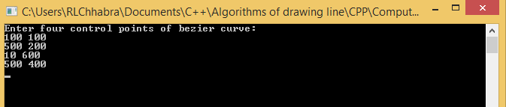

OUTPUT:-

